PROCESS SET UP OF TYNWALD.LIVE FOR TYNWALD DAY
tynwald.Live

Overview
Synergy have purchased the domain Tynwald.live on behalf of the Office
The website is hosted and configured through Scorch.
Started in 2020, it is a Tynwald Day to stream the visuals from St. John’s via a [Vimeo] embed from Greenlight.

Set Up
The site uses Wordpress.
Leading up to the ceremony there can be a countdown screen.
On the day, the countdown screen is replaced by a view that is split into two, one for the visual embed and one as a text box: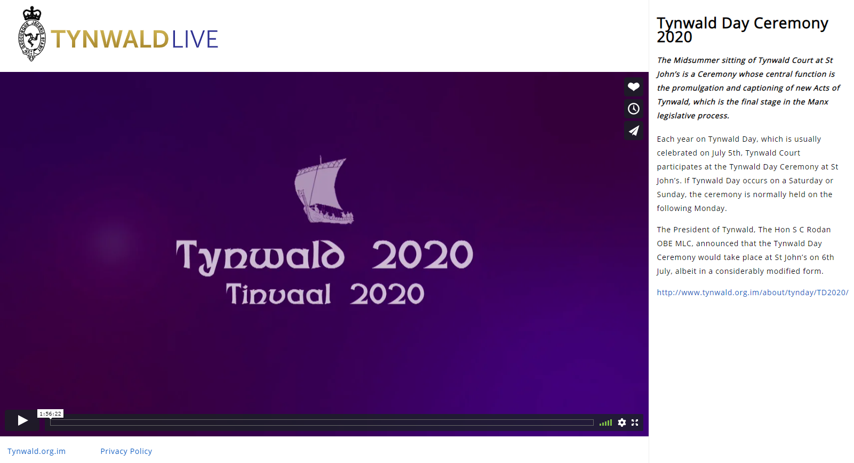
The text from the programme was used as a substitute for subtitles.
The office had a log in for the text box so anything could be typed in and anyone viewing the main page should see it updated in 10 second intervals.
LOG IN PAGE: https://tynwald.live/wp-admin/
(Try opening in a different browser if won’t connect)

Pages
Manx Language page for editing:
https://tynwald.live/wp-admin/post.php?post=6&action=edit

Holding page (we can switch this round on the day):
https://tynwald.live

Live page:
https://tynwald.live/homepage/

Updates
Text for Tynwald Day live stream is added to the main page called: Tynwald XXXX XXXX XXXX XXXX
Embed code for Tynwald Day live STREAM is added to the page: Main Page
The "Stream" option on this page points to the embed iframe src.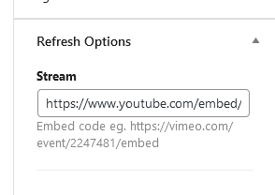
You can’t copy the basic share link – you need the embed code and extract the share:
Example html FOR VIMEO
<div style="padding:56.25% 0 0 0;position:relative;"><iframe src=https://vimeo.com/event/3532045/embed frameborder="0" allow="autoplay; fullscreen; picture-in-picture" allowfullscreen style="position:absolute;top:0;left:0;width:100%;height:100%;"></iframe></div>
BECOMES:
https://vimeo.com/event/4422321/embed/interaction
YOU TUBE
Find the OTB embed and extract the URL
<iframe width="560" height="315" src="https://www.youtube.com/embed/7py0f1WdtC8?si=paIDMLV8DaFRgTZF" title="YouTube video player" frameborder="0" allow="accelerometer; autoplay; clipboard-write; encrypted-media; gyroscope; picture-in-picture; web-share" referrerpolicy="strict-origin-when-cross-origin" allowfullscreen></iframe>
BECOMES:
https://www.youtube.com/embed/7py0f1WdtC8?si=paIDMLV8DaFRgTZF

The page can take a while to refresh
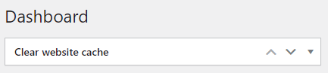
you can force it and wait:

Tynwald Day
Example text:
On Friday 5th July the Isle of Man will celebrate its National Day and at its core is the Tynwald Day Ceremony held at St John’s.
After a religious service in the Royal Chapel, the members of Tynwald process to Tynwald Hill, one of the ancient open air sites of Tynwald. Following the proceedings on Tynwald Hill, presided over by the Lieutenant Governor, the members of Tynwald return to the Royal Chapel where a formal sitting of Tynwald takes place.
The Ceremony will be broadcast live here from approximately 9am on Friday 5th July 2024.

Committee Text:
Committee Public Evidence Sessions
Tynwald Committee Public Evidence Sessions are streamed here. More information about Committees, along with a schedule of upcoming oral hearings, can be found here. Video recordings of oral hearings are available on our YouTube channel.
If you experience any difficulties accessing the videostream, please use our Listen Live service to follow proceedings.

Embed the Tynwald a video or playlist on YouTube

Login name: Tynwald Login pass: 2CKXVLk4mQAr@9nAPVUt5lEt

